Spring Boot

Enterprises javabeans Technology :
Enterprises javabeans technology is the server-side component architecture for java platforms,enterprises edition,EJB technology enables rapid and simplified development of distributed ,transactional,secure ,and portable application based on java technology .
EJB -server side component architecture.

so What is server and client ?
A server is a computer program or device that provides a service to another computer program and its user, also known as the client.

what is port ?
opening point for each connection which specifies the number of task can be handled using a single connection .
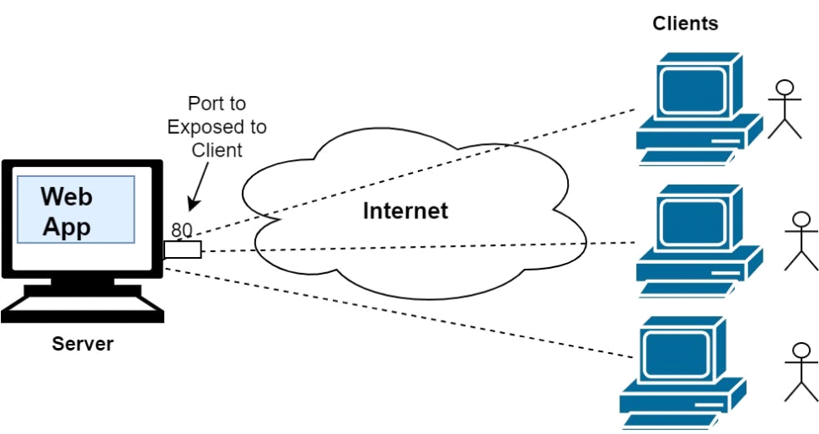

Hence to provide server side component architecture , certain groups of community came forward with frameworks to provide specialization in certain tasks in java .
eg: Hibernate - developed by linux (redhat)
spring - pivotal software

Spring : Introduction :
Spring framework provides a comphrensive programming and configuration model for modern java based on enterprise application on any kind of deployment platforms eg:(linux,mac,windows etc)
Features :
core technologies - dependency injection ,events ,resources , validation ,data binding,type conversion
Testing - mock objects , test context framework , spring mvc test
data access - transaction DAO support ,JDBC ,ORM, Marshalling XML.
Spring MVC and Spring Webflux framework
Integration - remoting ,JMS,JCA,email task ,sheduling cache
Language - dynamic languages

Spring Boot - Spring boot make it easy to create stand alone,production -grade spring based application that you can just run . Spring boot take a opnionated view of spring platform .
spring project features :
1. POJO (Plain old java Object) Class -Class with getter and setter (It can act as a table(Entity ) or data type )
2. Dependency Injection
3. Rest API
4. MVC
5. Security
6. Design Patterns
__________________________________________________________________________________
MVC :Model View Controller Architecture
Model :
1. Responsible for storing and retreving data
2.Maintenance of state
3.Notification of observers of changes in state .

view :
Responsible for rendering of model -UI
User interaction

Controller :
Responsible for responding to user input
instructing the model to respond to the user input

Hence MVC is loosely coupled as we split the operation to make the job easier and ease in enhancement .
__________________________________________________________________________________
REST API :(Representational State Transfer) ( brief in other document)
API - Application Programming Interface
__________________________________________________________________________________
Dependency Injection :
How one object is connected to the other objects or dependent to each other . how the dependency is made and put into the other class object.
it can be denotted with object graph .
it is the fundamental aspect of spring framework through which the spring contaier inject the object to the other objects or dependencies.
advantages of dependency injection :
1. avoids tight coupling
2.achieving using @ component , @ autowired ,@qualifier
3. attain unit testing easily using dependency injection

IDE for spring -Spring tool suite

Spring project provides
1. Default project structure
2.Dependencies auto download
3.auto compile
4.Server starting and stopping

Essential jar and war files used in spring :
1. Spring web - To handle the web application
2. thyme leaf - for handling frontend
3. JPA -for connecting DB
4. H2 Database -
5. Spring boot actuator- for debugging

Dependency injection using @Component:
1. Singleton scope :
whenever a new request is made for that bean, spring IOC container first checks whether an instance of that bean is already created or not. If it is already created, then the IOC container returns the same instance otherwise it creates a new instance of that bean only at the first request.

eg:
@SpringBootApplication
public class SpringFilters2Application {
public static void main(String[] args) {
ConfigurableApplicationContext context = SpringApplication.run(SpringFilters2Application.class, args);
Internet_Connection obj =context.getBean(Internet_Connection.class);
obj.connect();
Internet_Connection obj2=context.getBean(Internet_Connection.class);
obj2.connect();
}
}
------------------------x--------------------------
@Component
public class Internet_Connection {
public Internet_Connection() {
System.out.println("hi i am constructor!!");
}

public void connect() {
System.out.println("Internet connection successful");
}
}
Since the Internet_Connection class is created with singeton scope,only single object will be created and how ever we create two or more object name to call in different area, it will consider the single object name .

hence the output will be :
hi i am constructor!!
Internet connection successful -------------> o/p of obj
Internet connection successful -------------> o/p of obj2

__________________________________________________________________________________
2. Prototype scope :
If the scope is declared prototype, then spring IOC container will create a new instance of that bean every time a request is made for that specific bean.
A request can be made to the bean instance either programmatically using getBean() method or by XML for Dependency Injection of secondary type.
this can be attained by adding the annotation @Scope(value="prototype") in the component class .
What does spring application.run() do
-setup default configuration
-starts spring application context
-start tomcat server
-class path scan (search the desired class which is mentioned as object using @component )
__________________________________________________________________________________
Dependency Injection using @Autowired :
Spring container can autowire relationships between collaborating beans. This is called Spring bean autowiring. Hence the object created with @component can be mapped using @autowired(requires=true), to call the specific object among different other object the class must be mapped by using @component("abc") a identifier inside the bracked which can be autowired using @Qualifier("abc") . This brings the object to connect with each other .
difference between autowired and qualifier is that autowired search by its type ,qualifier search by component's name.
eg:
@Component("abc")
public class Lan_Connection {
public void ip() {
System.out.println("ip address is 103.45.35.23");
}
}
__________________________________________________________________________________
@Component("cab")
public class Internet_Configuration {
@Autowired(required=true)
@Qualifier("abc")
private Lan_Connection obj;
private float ip_Address;
private String domain;
public float getIp_Address() {
return ip_Address;
}
public void setIp_Address(float ip_Address) {
this.ip_Address = ip_Address;
}
public String getDomain() {
return domain;
}
public void setDomain(String domain) {
this.domain = domain;
}
public void switchon() {
obj.ip();
System.out.println("the internet connection configuration is successful");
}
}
__________________________________________________________________________________
Servlet :
Http request is sent from the server and the response will be received from server to the client.
There are two types of request :
- static request
- dynamic request
Static request:
Static Web pages are very simple. It is written in languages such as HTML, JavaScript, CSS, etc. For static web pages when a server receives a request for a web page, then the server sends the response to the client without doing any additional process.
Dynamic request:
To handle dynamic request server seeks the help of a web container .
The web container will manage the dynamic request and response as dynamic.
A web container handles requests to servlets, Jakarta Server Pages (JSP) files, and other types of files that include server-side code.
The Web container creates servlet instances, loads and unloads servlets, creates and manages request and response objects, and performs other servlet-management tasks.
